Smart Career Readiness Platform
USE-CASE DESIGN:
A use-case diagram represents the interaction between users (actors) and the system functionalities:
Actors Identified
- Student – Uses the platform to assess career readiness and improve skills
- Admin – Manages system data and monitors platform usage
- Use-Cases for Student
The student interacts with the system to evaluate skills and receive career guidance: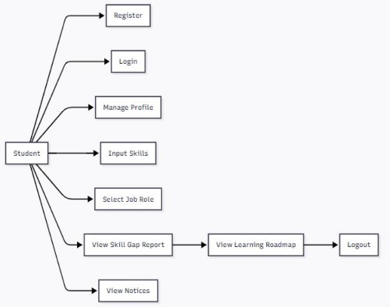

1. Register
- Student creates a new account in the system
- Required for first-time users
2. Login
- Student logs in using email and password
- Provides secure access to the platform
3. Manage Profile
- Student updates personal and educational details
- Helps in accurate career assessment
4. Input Skills
- Student enters current technical and soft skills
- Used for skill gap analysis
5. Select Job Role
- Student selects a desired job role
- System compares required skills with student skills
6. View Skill Gap Report
- Displays missing skills and readiness percentage
- Helps student understand improvement areas
7. View Learning Roadmap
- Shows personalized learning path
- Guides the student step-by-step
8. View Notices
- Student views academic and placement updates
- Keeps student informed
9. Logout
- Student safely exits the system

Use-Cases for Admin
The admin manages content and system operations:
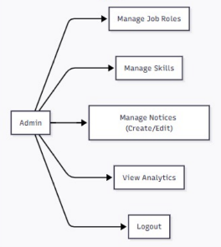
1. Manage Job Roles
- Admin adds, updates, or deletes job roles
- Ensures roles match industry requirements

2. Manage Skills
- Admin maintains the skill database
- Keeps skills updated and relevant
3. Manage Notices (Create/Edit)
- Admin publishes academic and placement notices
- Controls visibility and priority
4. View Analytics
- Admin monitors student usage and readiness trends
- Helps in decision-making
5. Logout
- Admin securely logs out of the system

UI Figma link:
https://www.figma.com/proto/k3np5xcU4lz32TXyHhN7h9/Untitled?page-id=0%3A1&node-id=36-92&p=f&viewport=160%2C274%2C0.17&t=zGp2mPiLITa9TrKQ-1&scaling=min-zoom&content-scaling=fixed

